**LAB 1** 

Name Jack R

Objectives:

• Setup compiler environment and become familiar with it

• Learn basic debugging and compiling

1) From the class handout notes choose one of the environments (IDE’s) and set them up. (visual studio, JetBrains Clion (needs education license, see notes on obtaining one for free), on linux use g++,….) If you don’t have one available for your OS, then get familiar with an environment such as repl. https://repl.it/languages/cpp

Note you will have to create a repl account to use all the features. It is free.

Some Screen shots are used from repl since it is available to all operating systems and environments. 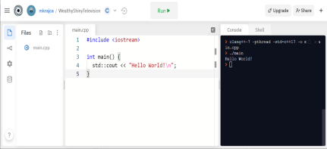

Most IDE’s will have some sort of a rum button. On repl it is the center of the screen. Click it and see if your program compiles. Output should be in the console window. Almost all IDE’s will create some sort of basic code when you create a project. If you don’t have one type in the code that was in the repl screenshot.

In repl we can use most Linux commands to compile including G++.

In the shell type:

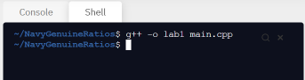

The right-hand side should now have a new file:

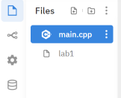

G++ is the c++ compiler. The -o tag tells it to create an executable named lab1. Note in Unix you don’t have to use .exe extension. We can run the executable by typing in Repl by default use another c+= compiler called “clang” 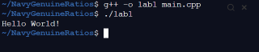

./lab1

We can use other Unix/Linux commands to such as “ldd” to see what libraries were compiled in to out exectable. 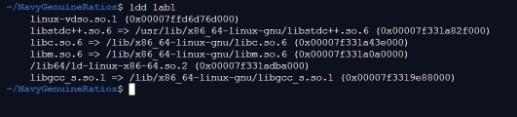Most of these commands for debugging are not available on windows using visual studio or Clion (at least not easily) Visual studio:

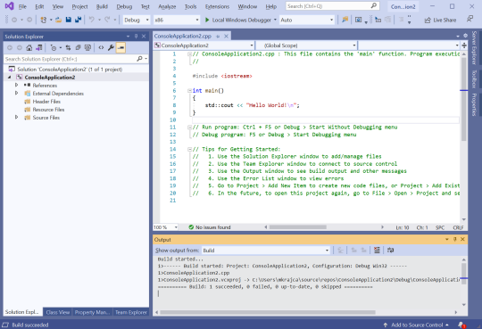

Press CTRL + F5 for output window.

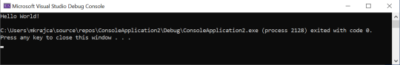JetBrains Clion:

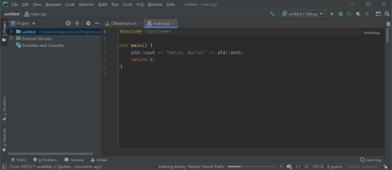Click the in the menu bar

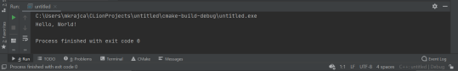

2) After you get familiar with the basic environment. Type in the following code.

#include <iostream>

using namespace std;

int main() {

cout << "Orange county community college" << endl; cout<<"lab1"<<endl;

int x; // integer variable

int y; // integer variable;

x = 20;

y = 5;

cout<<"X + Y = " << x + y<<endl;

return 0;

}

Run the program. (compile and run)

What is the output of the program? 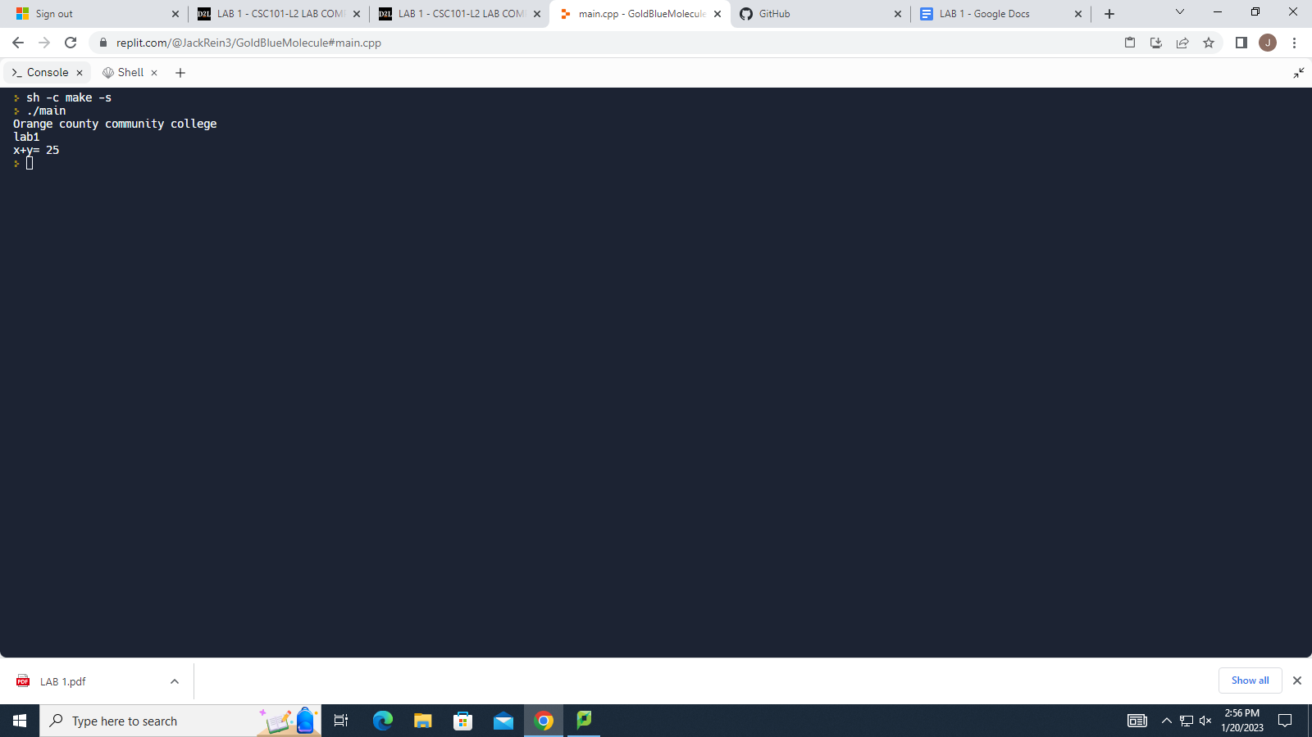

Delete the semicolon on line 8. Where x=20

#include <iostream>

using namespace std;

int main() {

cout << "Orange county community college" << endl; cout<<"lab1"<<endl;

int x; // integer variable

int y; // integer variable;

x = 20

y = 5;

cout<<"X + Y = " << x + y<<endl;

return 0;

}

Try to compile the code again.

Did it compile? If not what kind of error did you get?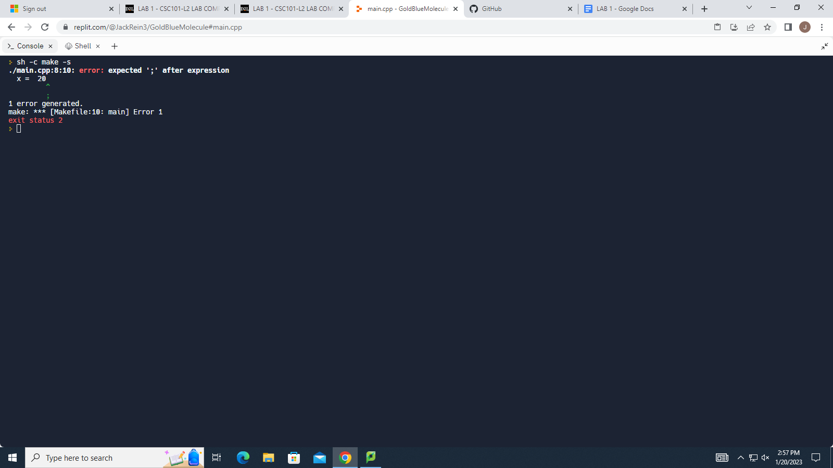

Put back the semicolon and try to compile again.

Did it compile? Yes it did compile this time

Sometimes a program will compile but does not have the correct output. Most IDE’s will have some sort of a trace feature or debug mode. However, if you are working on projects on Unix Linux that are remote (such as working on a project in Amazon cloud, or most cloud services there is not IDE available. Also, most embedded microcontrollers that have specialized CPUs the only way to debug is on the printout statements or using some other hardware such as Jtags (beyond the scope of this class)

Debugging manually is the only way to trace the program. We use “cout” to see the content of variables at runtime. Modify the above program as follows:

#include <iostream>

using namespace std;

int main() {

cout << "Orange county community college" << endl;

cout<<"lab1"<<endl;

int x; // integer variable

int y; // integer variable;

x = 20;

cout<<"content of X right after initialization: " << x << endl; y = 5;

cout<<"X + Y = " << x + y<<endl;

cout<<"content of y right before program exit: " << y << endl;

return 0;

}

What kind of output did you get? Were you able to see the values of x and y during the program execution?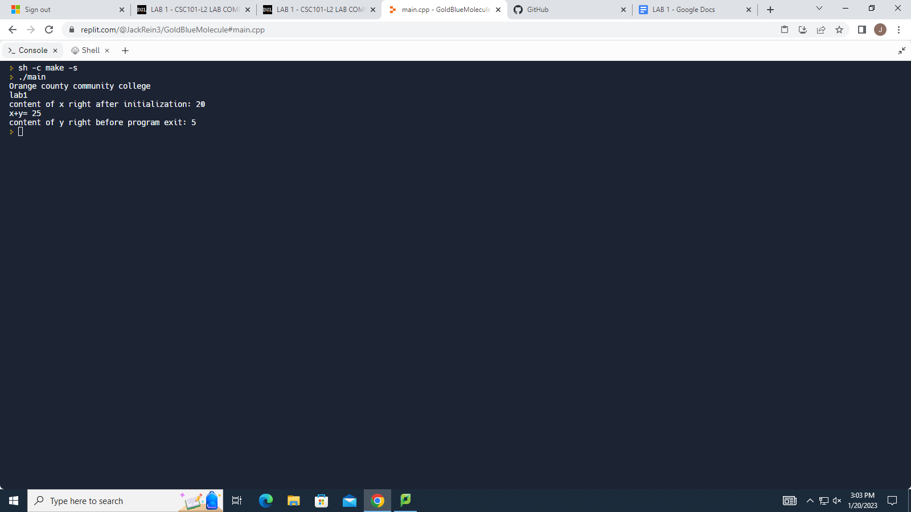

Comment out the debugging “cout” statements”

#include <iostream>

using namespace std;

int main() {

cout << "Orange county community college" << endl; cout<<"lab1"<<endl;

int x; // integer variable

int y; // integer variable

x = 20;

//cout<<"content of X right after initialization: " << x << endl; y = 5;

cout<<"X + Y = " << x + y<<endl;

//cout<<"content of y right before program exit: " << y << endl;

return 0;

}

Run the program. Did the contents of x and y display during the run of the program? No this time it did not display the contents of x and y during the run of the program

Create a banner for your program. You should have a banner on your labs when you hand them in. The banner should print out the Your name, class, lab number(or assignment) and the date.

Example:

#include <iostream>

using namespace std;

int main() {

cout<<"--------------------------------"<<endl;

cout << "Miroslav Krajca" << endl;

cout<< "Computer Science 1"<<endl;

cout<< "Lab1"<< endl;

cout<< "January 27, 2021" << endl;

cout<<"--------------------------------"<<endl;

int x; // integer variable

int y; // integer variable;

x = 20;

//cout<<"content of X right after initialization: " << x << endl; y = 5;

cout<<"X + Y = " << x + y<<endl;

//cout<<"content of y right before program exit: " << y << endl;

return 0;

}

Paste the final code into your lab and turn it in.